LAB ASSIGNMENT 4.1 [2403A51336]

13-08-2025

task1:

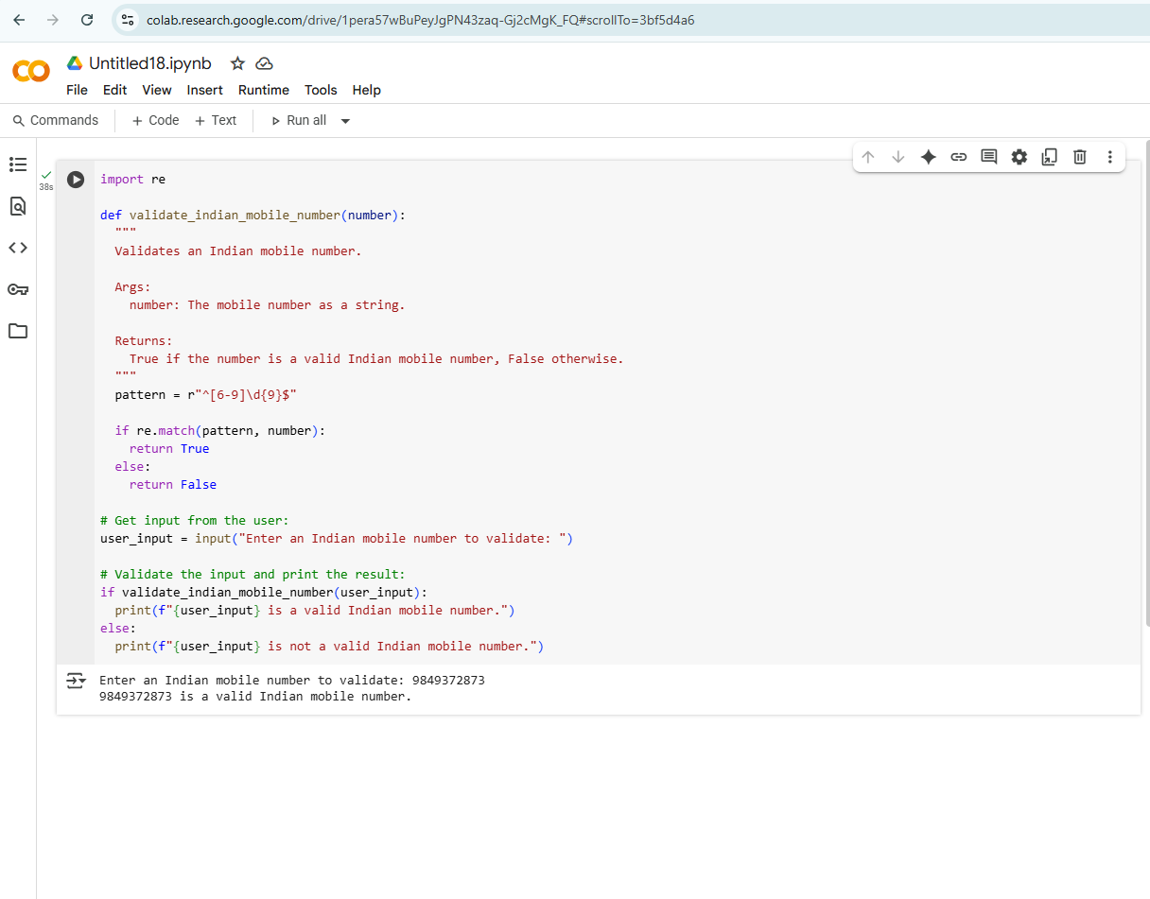

task2:

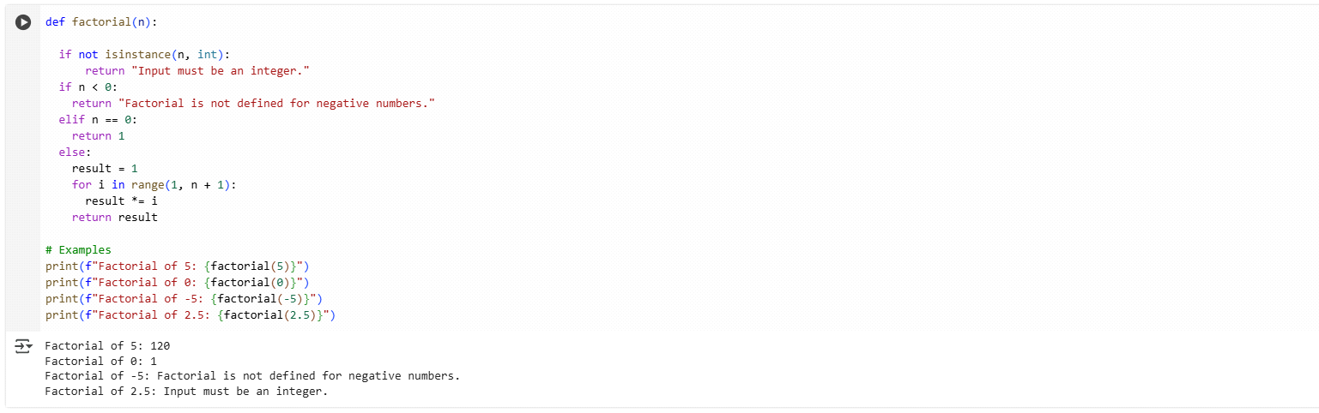

task 3:

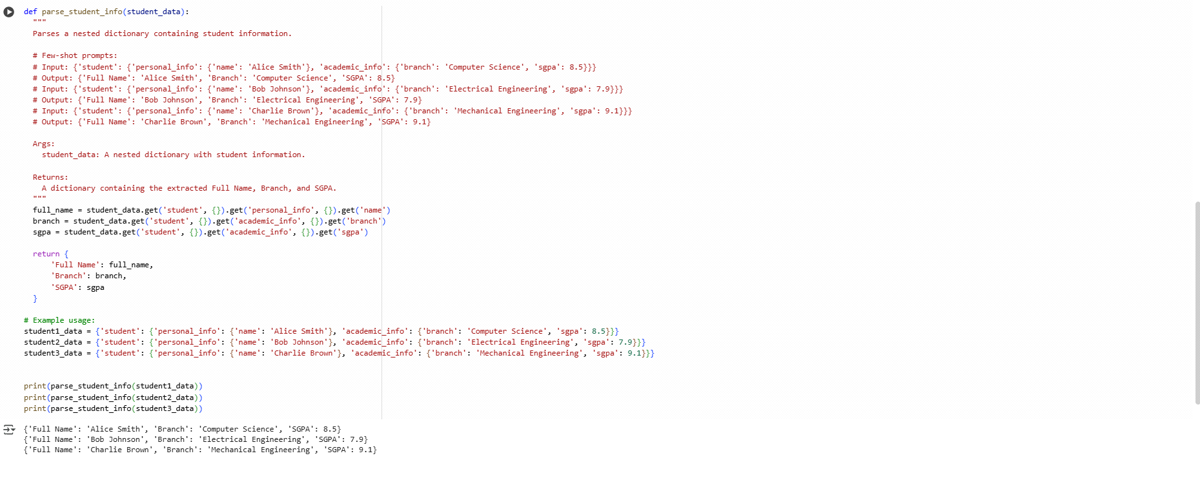

task 4:

Zero-Shot Prompting

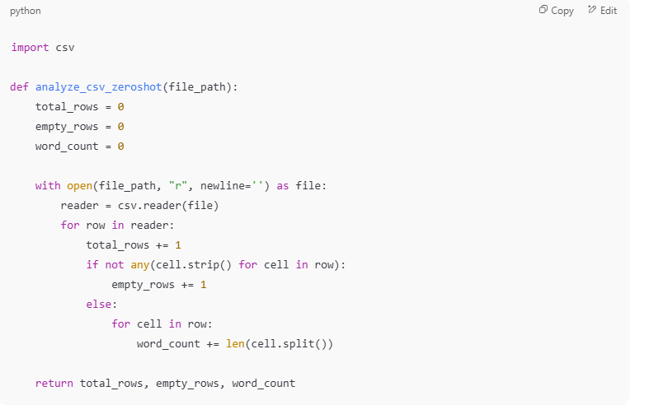

One-Shot Prompting:

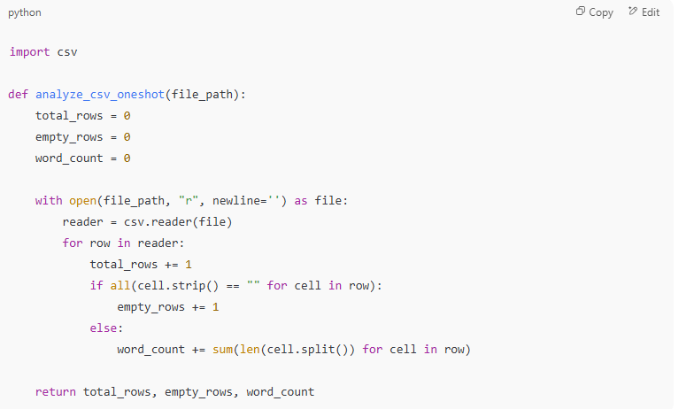

Few-Shot Prompting:

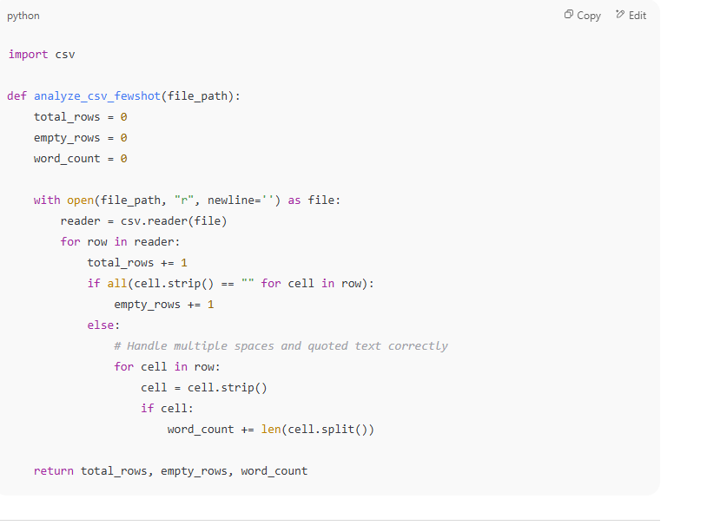

output:

